

***Department***

***Riphah School of Computing and Innovation***

***(RSCI)***

***Name :- Syed Hussain Hali***

***Sap Id :- 25127***

***Section :- BSCS-6B***

***Subject :- Artificial Intelligence***

***Submit To :- Ms.Ayesha Kashif***

***LAB INSTRUCTOR: Mr.Abdul Aleem***

**Lab Assignment (1)**

**Q1**

**Obtain the dataset from [ https://www.hackerearth.com/practice/machine-learning/machine-learningalgorithms/beginners-guide-regression-analysis-plot-interpretations/practice-problems/ ].**

**Answer**

The dataset which I used for the problem is specifically predict the lowest price

**Q2**

**Describe the problem in your own words ?**

**Answer**

In this dataset we are given given Item_ID, Date, state of country, market category, grade, demand, high_cap_price & low_cap_price and we have to predict the low_cap_price

**Q3**

**Explain how linear regression can help solve this problem.**

**Answer**

Linear regression helps solve this problem by Data Collecting, exploring that data, preparing that data, doing model training on it, doing model evaluation on it & then by doing prediction.

**Q4**

**Which software you used for that problem (Hint: Utilize GPU for faster model training.)**

**Answer**

Google Collaboratory I used because as previous I find it eassy due to easy to use and work as regular base. So I prefer this.

**Q5**

**Are you use the headings and comments to show your code Professional ?**

**Answer**

Yes I added the comments and headings on code lines.

**Q6**

**Follow the ML lifecycle to solve the problem and provide separate code sections for each stage.**

**a. Include detailed screenshots of any errors you encountered while working with the dataset.**

**b. Explain what the error is about.**

**c. Describe how you resolved the error.**

**d. Provide the query you wrote to solve your error.**

**e. Share the solution.**

**Answer**

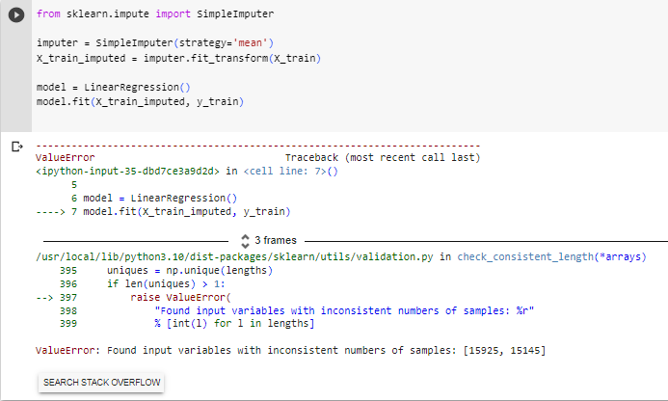

String error due to float

Solution : I chose specific values which are not in float.

Again error as above. The solution is same

Same as above error and error not fixed that time due to datatype.

Float are not datatype that convert to fixed number of characters

Solution : Choose specific data.

Use big letter instead of small.

**Q7**

**Add more graphs in code to visualize specially train_test graph ?**

**Answer**

Yes graphs are included to visualize specially train_test graph.

**Q8**

**Use RMSE as accuracy measure try to minimize this as you can ?**

**Answer**

Yes RMSE accuracy include on it.

**File Link of GitHub :-**

**https://github.com/huss-01/Lab-Assignments**